THE ROLE OF THE NCO IN LEADERSHIP, PART I

Subcourse IS 7034

THE CENTER FOR ARMY LEADERSHIP
UNITED STATES ARMY COMMAND AND GENERAL STAFF COLLEGE
Fort Leavenworth, Kansas 66027

7 Credit Hours

Edition Date: April 1991

SUBCOURSE OVERVIEW

This subcourse is designed to teach the basic doctrinal factors and principles of the leadership process. It provides the foundation for subsequent leadership subcourses in this series. The traditional principles of leadership have long been the cornerstone of our leadership doctrine. The leadership factors, leadership competencies, and the BE, KNOW, and DO attributes provide you with the fundamentals of leadership and a framework for both self-development, and the development of your soldiers.

"The Role of the NCO in Leadership" subcourses (IS 7034 - IS 7037) are geared to meet the needs of the corporal through sergeant first class in the area of practical leadership application. These courses were written to complement the leadership instruction taught in NCOES. You do not have to be a PLDC graduate to take these courses but most of the material will build on that instruction. Some of you will take this subcourse before you attend PLDC or BNCOC. It will give you a good introduction to leadership principles. The most important reason for studying these subcourses is to give you additional information that will help you to be a better leader. The booklets are yours to keep, refer to them often.

If you have any questions pertaining to this subcourse please fill out one of the pre-addressed student inquiry sheets in the back of the booklet.

There are no prerequisites for this subcourse.

This subcourse reflects current doctrine. In your work situation always refer to the latest publications.

Use of a specific gender in this publication is for ease of reading. Whenever the masculine or feminine gender is used, either gender is intended.

Since this subcourse, IS 7034, presents the basic doctrinal factors and principles of leadership, it is necessarily linked to each of the nine leadership competencies.

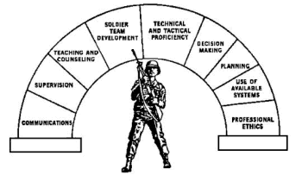

IS 7034 - The Role of the NCO in Leadership
Reinforces all 9 Leadership Competencies

TERMINAL LEARNING OBJECTIVE

TASK: | Define leadership and explain the basic doctrinal factors and principles of the leadership process.
CONDITIONS: | Given subcourse instructional materials.
STANDARDS: | As a minimum, your definition of leadership must include the elements of purpose, direction, and motivation and your explanation of basic doctrinal factors must include:
The 11 principles of leadership.
The four factors of leadership.
The professional Army ethic.
Military professionalism.
The leadership competencies.

